|  |
| --- |
| UZB DESIGN AND DEVELOPMENT |
| SLOT MACHINE |
| **[COMP 397 Slot Machine]** |
| Version #1.1  All work Copyright © 2012 by XX Games.  All rights reserved. |
| **Noel Euzebe]** |
|  |



|  |
| --- |
| Oct 24th 2014 |

**Table of Contents**

Contents

Version History 3

Game Overview 4

Game Play Mechanics 4

Controls 4

Interface Sketch 4

Scoring 4

Art Index 5

# Version History

Version 1.0

* Created basic functionality
* Added to version control

Version 1.1

* Added GUI and image assets

## Game Overview

*The goal of the slot machine game is to provide a realistic user interface similar to that of a real slot machine. The slot machine has five independently spinning reels which each have a one in six chance of stopping on one of the available symbols.*

### Game Play Mechanics

*The player selects their bet amount by clicking one of the appropriate bet choices. If the player has insufficient funds, they will not be allowed to select bet amounts. Once the bet has been selected, the player then clicks the SPIN button. The slot reels then randomly select the symbols for that roll. Based on the spin results, the player will win or lose. If the player wins, their win bonus will be dependent on what symbols comprised the roll.*

### Controls

*The mouse is used to select choices. These include betting, quitting, resetting and spinning.*

### Interface Sketch

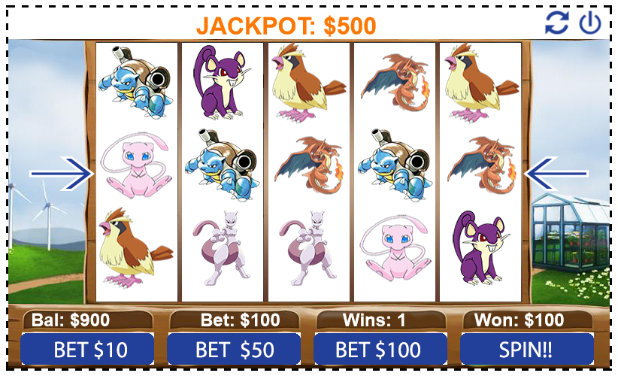

### Scoring

Score is kept by the player's winnings. These winnings are gained as a result of spinning and getting successful rolls.

### Art Index

  
